Karnataka Law Society’s

Gogte Institution of Technology

Udyambag Belgeum-590008

“Applied Mathematics”



Project Report on:

Application Of Statistics in Engineering Technology Programs

Submitted by:

|  |  |  |  |  |
| --- | --- | --- | --- | --- |
| **Sr.no** | **Name of  Student** | **USN** | **Roll no.** | **Signature** |
| 1 | Venkatesh Dhongadi | GIT19CS114-T | 1339 |  |
| 2 | Atreay Kukanur | GIT19CS180-T | 1354 |  |
| 3 | Rahul K | GIT19EC107-T | 1311 |  |
| 4 | Sudesh Rao | GIT19IS033-T | 1343 |  |

Submitted to: Mr.’s P V Adhyapak

**INTRODUCTION:**

Statistics is a critical tool for robustness analysis, measurement system error analysis, test data analysis, probabilistic risk assessment, and many other fields in the engineering world.

During the past two decades there has been a trend in industry to use management philosophies, with an emphasis in the systematic use of statistical methods. The Japanese manufacturing industry has made a tremendous improvement in quality because of the wide use of statistical methods such as Total Quality Management. Other statistical tools such as Statistical Process Control (SPC) and Six Sigma have also been proven effective in improving processes, product quality, and corporate bottom lines. For example, Motorola credited the Six Sigma initiative for saving $940 million over three years and AlliedSignal reported a $1.5 billion savings in 1997. Other companies responded to the quality competition by adopting these statistical methods. For industries such as the pharmaceutical and manufacturing industries, tools such as Six Sigma have become required knowledge for a successful engineer.

Three decades ago, the American Statistical Association claimed that industry needed engineers with experience and knowledge of statistics. Most engineering students thought that the probability and statistics courses were difficult, boring, and useless. These courses were too theoretical and appeared to be unrelated to the engineering subjects they studied. As pointed out by Godfrey in his classic work: “We too often teach what appears to the students a collection of unrelated methods illustrated by examples taken from coin tossing, card-playing and dice-rolling. And then we expect the students to be able to translate this wide variety of methods with simple gambling examples to complex industrial problems involving the application of a large number of methods”. Since then many educators have realized that the situation in statistics education needs to be changed. The needs from industry have led to a continuing effort to enhance the education on statistics. Many statistics courses now use real-world examples, real data, and simulation to help students learn more effectively. A lot of work has been done to improve the teaching and learning of statistics. But the task is becoming more challenging: as the education on statistics is improved, the demands from today’s industry are outpacing the improvement in education.

Even though intensive statistical courses are included in most traditional engineering curricula, historically, statistics is not extensively applied in undergraduate engineering technology (ET) programs. Usually the students take a statistics course from the Statistics Department as a prerequisite for other engineering courses and seldom use the knowledge they learned in any follow-on courses. They are rudely awakened when they graduate from college and are faced with real-world statistics-based engineering tasks in their first jobs. By then they have forgotten most of what they learned in the statistics course, or they do not know how to relate the statistical knowledge to the engineering applications encountered in the real world. Similar realistic evaluations in other traditional engineering programs such as chemical engineering biomedical engineering, civil engineering industrial engineering, mechanical engineering, and electrical and computer engineering have led to increased curricular development efforts, primarily in engineering based statistics. However, educational research in statistics by ET programs is very limited. Part of the reason for this is that ET students typically focus on hands-on experiences and do not like theoretical analysis. Statistics, however, can be used as a very practical tool, especially in the area of measurement and testing, which is a main focus area in many ET programs. Although some results in statistics education in the literature can be applied directly to ET, the uniqueness of the students and the program requires special effort to make the teaching/learning of statistics more effective.

There have been several research efforts in the area of using statistics-related tools in ET programs that focus on specific tools in specific courses.

**Keywords**: Engineering education; error analysis; Monte Carlo methods; simulation; statistics.

“How to effectively integrate statistics in the entire curriculum of ET programs?”

METHODOLOGY:

Statistics is an important tool for robustness analysis, measurement system error analysis, test data analysis, probabilistic risk assessment, and many other fields in the engineering world. The key to the success of teaching statistics to engineering students is to make the statistics solution relevant to the engineering problems they face. Using real-world data and real-world problems is an important approach practiced by many educators. The Particular General Particular (PGP) strategy used by Mosteller (Mosteller 1980) and Romero et al. (Romero et al. 1995) can be very effective. Active participation by the students during the teaching and learning of statistics is a good method to use to integrate the student into the teaching of statistics. Using simulation instead of theoretical derivation also shows promise for ET students. Using Excel to perform basic statistical analysis is also a very attractive option. Project-based learning is another method used widely in ET programs, since laboratory exercises are one of the main learning tools for ET students. Standridge and Marvel presented a strong case for teaching statistics to engineering students in a laboratory course. Early exposure and repetition is an effective approach of learning whether it is statistics or other knowledge.

The critical ingredients found in the published educational research on teaching and learning of statistics that can be potentially adopted by ET programs are summarized as follows:

* Using real-world data and problems
* Active learning of students
* Using software and simulation
* Using statistics in laboratories and projects
* Early and frequent exposure to statistics.

Qualifications:

Based on the approaches that potentially can be effective for ET programs in the education of statistics, a learning-by-using approach was applied in several courses in the Electronics ET program at Texas A&M University. This pilot project was started in the Spring semester of 2009, and it is an on-going effort. A total of eighty-nine students participated in this project. These students are from four courses out of the total of eighteen courses offered by the Electronics ET program, which is about 22% of the courses. Seventy-eight valid student survey sheets were collected for statistical analysis purposes. The results presented in this paper are preliminary. The effort will be continued and expanded to more courses. More data will be collected for the evaluation of the effectiveness of the proposed statistics teaching method. Future research can be conducted to quantitatively and qualitatively evaluate the effectiveness of this approach through student and faculty surveys, and feedback from former students and industry. Among the eighty-nine students participated in this pilot project, about one fourth of them took the survey in two separate courses in sequential. This might have made the data somewhat skewed compared to the case where students were exposed to the learning-by-using approach for the first time. The latter case would have a more dramatic improvement over a semester. This is another potential subject for further research and is not discussed in this paper.

The main idea of the new approach is to use basic statistical concepts in as many courses in the curriculum as possible, with an emphasis on using statistical tools in the laboratory and course projects to solve real engineering problems. In addition to a stand-alone statistics course from the Statistics Department, within the program, statistical analysis methods and tools are introduced to the students to solve engineering problems whenever appropriate. The learning of statistical tools and concepts is based on real-world data and examples. After presenting the examples, the students are asked to use the statistics tools to solve problems they face in laboratories and projects. Software packages, such as Excel and Minitab (Meyer and Krueger 2005), that are easy to use were selected to conduct the statistical analysis. The learning of statistics is not limited to one course, so that the students first get exposure to the tools in a sophomore level circuit analysis course followed with repeated exposure in several other courses in the following semesters, with increased intensity and depth. The goal is to have students understand that statistics is not just a course that they must take and then can forget about; instead it is a useful tool that they need to master in order to do a better job as an engineer. It is worth noting again that the new approach proposed in this paper is not a replacement of the existing statistic courses or a newly created stand-alone course; instead, it adds to the broader application of statistics throughout the curricula of engineering technology programs with an objective of applying statistics to solve engineering problems.

Examples of teaching statistics in various courses are given to illustrate the implementation of the new approach.

Parameter uncertainty and part-to-part variation:

The concept of parameter uncertainty due to part-to-part variation was introduced to the students early in a sophomore level class, when electronic circuits were designed and analyzed. The determination of tolerance bands for electronic parts was discussed using statistical terms such as normal distribution, mean, and variation. Students were asked to take the variations in the parameters into consideration when they conducted experiments in the laboratories. Discussion in their laboratory reports must include discussion on the variations in their test data and how they were related to the parameter uncertainty. The Monte Carlo analysis (Casella 2004) tool in Multisim (Reeder 2006) was introduced in the circuit analysis course. Students were asked to conduct Monte Carlo analysis for a circuit and compare the simulated results to the actual test data.

Mean and standard deviation:

Mean and standard deviation are two statistical concepts that are very important and easy to understand. They are discussed in several courses using real-world examples. The calculation of the mean and standard deviation can be easily done using Excel or other software. A particular example that helps students understand how these can be used in engineering applications was illustrated with test data from a faculty research project involving wireless communication (Zhan and Goulart 2009). In this example, six different tests were conducted under four different test conditions (using different wireless cards and at different locations). The mean and standard deviation from each condition were used to calculate the signal-to-noise ratio (SNR) for the bandwidth of the wireless communication using the following formula

SNR = mean  
 stdev …. (1)

|  |  |  |  |  |
| --- | --- | --- | --- | --- |
| **Test No.** | **Condition 1** | **Condition 2** | **Condition 3** | **Condition 4** |
| 1 | 4.0 | 2.0 | 16.7 | 14.3 |
| 2 | 3.3 | 2.2 | 25.0 | 14.3 |
| 3 | 2.5 | 2.5 | 20.0 | 12.5 |
| 4 | 1.9 | 2.3 | 20.0 | 12.5 |
| 5 | 2.3 | 2.0 | 14.3 | 12.5 |
| 6 | 3.1 | 1.9 | 25.0 | 12.5 |
| **Mean** | 2.85 | 2.15 | 20.17 | 13.10 |
| **stdev** | 0.76 | 0.23 | 4.32 | 0.93 |
| **SNR** | 3.73 | 9.52 | 4.67 | 14.09 |

Table1. SNR for bandwidth

Without statistical analysis, one might come to the conclusion that Condition 3 is the best condition. Using the SNR defined in (1), it is clear that test condition 4 had the best signal-to-noise ratio among the four test conditions, while condition 3 was not even as good as Condition 2. Students in ET face similar scenarios in many projects throughout their education. This example provides a simple application of the use of statistical tools in solving engineering problems.

Six Sigma:

A presentation on Six Sigma and its application in real-world problems was prepared for students in both a junior level instrumentation courses as well as the senior design course. The concept of reducing the variation in processes to improve the quality of a product is illustrated in Fig. 1. The DMAIC process of Six Sigma was briefly introduced in the presentation. Practical statistical analysis tools, such as Design of Experiments, Monte Carlo analysis, Gauge R&R, ANOVA, probability test, and regression were introduced to the students in the context of Six Sigma. Four Six Sigma projects for improvements of an intelligent weather based traffic control system were successfully completed in the instrumentation course.

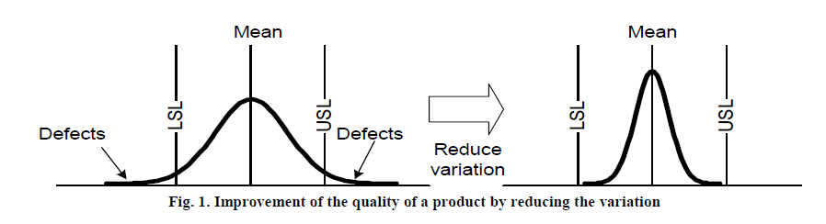

Design of Experiments:

The Design of Experiments (DOE) technique is usually not discussed in an undergraduate statistics course. However, the tool is very important for test engineers. With the help of software such as Minitab, the design and analysis aspects of DOE become fairly straightforward. In DOE, a problem is defined first. Second, factors and levels are chosen. Third, the response variables to be measured are selected. Fourth, a test matrix is created using Minitab. Finally, experiments are conducted to acquire data. Software such as Minitab can be used to perform statistical analysis. This process is illustrated with an example from the wireless research project discussed earlier. The result of the DOE analysis for jitter in a wireless communication is plotted in Fig. 2. It is evident based on Fig. 2: The three major contributors to the jitter can be identified as packet size, location, and wireless card selection.

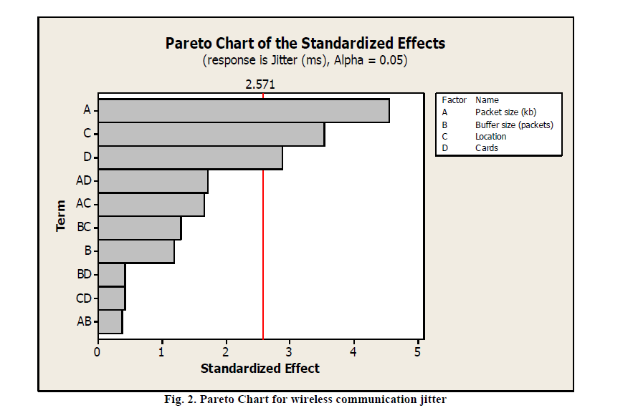

Repeatability and Reproducibility (R&R):

Taking measurements is an important task for ET students. They must understand that there are many sources for error in measurements. A key part of the measurement system analysis (MSA) is the analysis of repeatability and reproducibility of the measurements. The analysis of variance (ANOVA) can be used to estimate the contributions from the technician, the part-to-part variation, their interaction, and repeatability to the variation in the measurements.

Three teams of students used five signal-conditioning circuits with identical design to take temperature measurements. Table 2 shows the result of the ANOVA analysis. It can be seen that R&R accounts for 64.84% (= 44.27%+20.57%) of the total variance. The class came to the conclusion that better equipment and appropriate training for the technicians could significantly reduce the variance.

**Table 2. ANOVA Table (alpha=0.05)**

|  |  |  |  |  |  |  |  |  |
| --- | --- | --- | --- | --- | --- | --- | --- | --- |
| Source | SS | DF | MS | Fcal | F(alpha) | Var | Adj Var | % |
| Technician | 1204.17 | 2 | 602.09 | 22.54 | 3.68 | 57.54 | 57.54 | 44.27 |
| Part No. | 1203.99 | 4 | 301.00 | 11.26 | 3.06 | 45.71 | 45.71 | 35.17 |
| Interaction | -1604.61 | 8 | -200.58 | -7.50 | 2.64 | -113.65 | 0.00 | 0.00 |
| Error | 400.96 | 15 | 26.73 |  |  | 26.73 | 26.73 | 20.57 |
|  | total DF | 29 |  |  |  | total | 129.98 | 100.00 |

Regression:

Regression is a useful tool for engineers. It could help the engineer identify the relationship between variables based on test data. An example from a motor speed control research project was used to illustrate how to use regression to derive a function relating two variables. Fig. 3 is the simulated data, which is used to derive equation (2) using the least square regression method.

 …. (2)

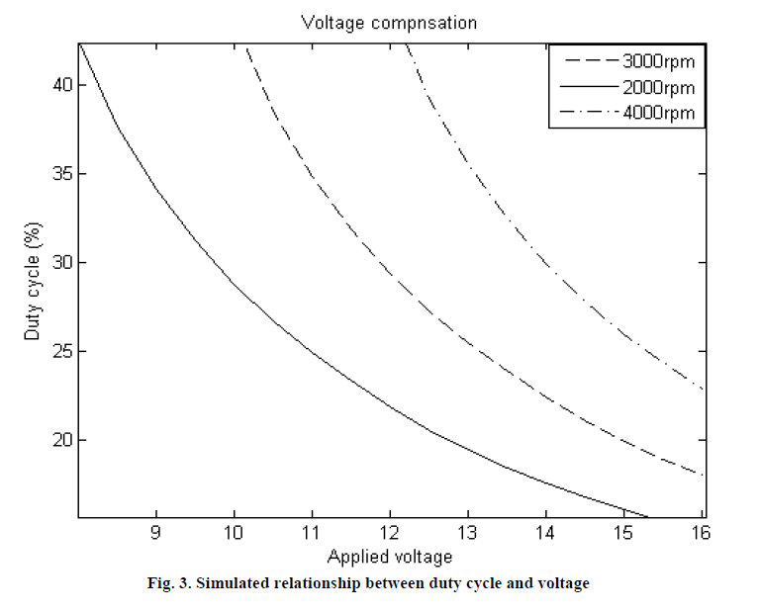

Monte Carlo Analysis:

Monte Carlo analysis was first introduced in a sophomore circuit analysis course where students used Multisim to conduct the analysis of the effects of the resistance and capacitance distributions on the cut-off frequency of a low pass filter. This was re-enforced in a junior level instrumentation course, where results from the motor speed control research project were used to illustrate the use of the Monte Carlo analysis method. First, a MATLAB (The MathWorks, Inc. 2008) model was built for simulation. One thousand sets of motor parameters were randomly generated in a MATLAB script file and used to simulate the average speed error during PWM control. Using the simulation data, statistical analysis for the average speed error was conducted. Mean, standard deviation, confidence intervals, and other statistical values were calculated, as shown in Fig.4

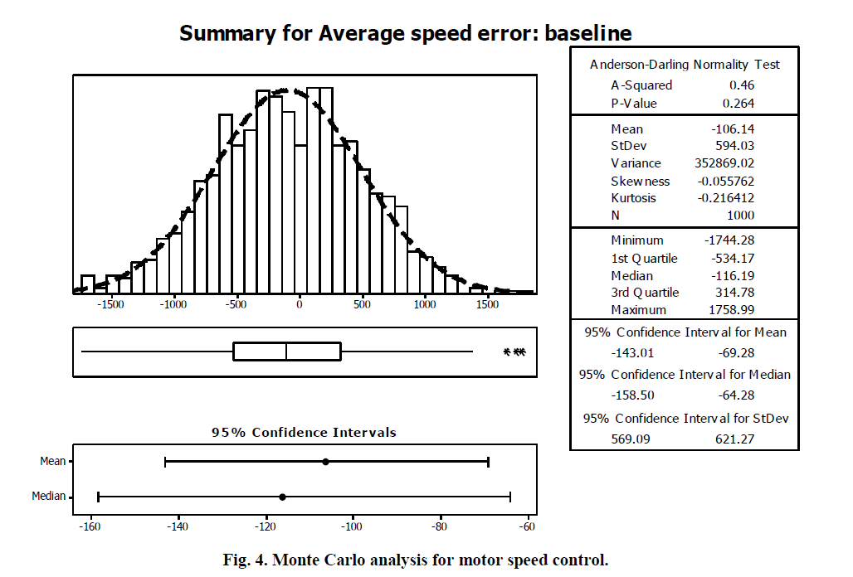

The real-world examples discussed here were presented in laboratory sessions or course projects. They were introduced as opportunities for students to use these tools to solve problems or improve designs. Real life projects were employed to bring out the application of statistics in engineering rather than using the approach of memorizing theory, simply to get a good grade. These examples worked exceptionally well for the specific courses and projects where they were employed in the ET programs at Texas A&M University. For the learning-by-using approach to work, the instructor must carefully select the examples and statistical tools such that examples are from real-world problems and the specific tools are relevant to the tasks faced by the students. It is also critical to make the use of tools straightforward, for example, use of Excel, Minitab, or other software is more effective than presenting theories and formulas to students.

RESULTS AND ANALYSIS:

The effectiveness of the new approach for applying statistics in ET programs at Texas A&M University is analyzed based on the following set of data:

* Examples of student work using statistical tools;
* Student surveys conducted in the beginning and the end of each semester;
* Percentage of statistical tool utilization in the final reports of course projects.

Application of statistical tools by students:

Selected examples of students using statistics in their course projects are presented here to illustrate the effects of the new approach.

Example 1: A student team in Mixed-Signal Semiconductor Testing course used 100 DAC0808 (8-bit current output Digital-to-Analog Converter produced by National Semiconductor) chips and five different testing methods to analyze the correlation among different methods in their course project. The average errors are summarized in Table 3. Student errors were compared to the instructor error to verify that a common solution was reached. In DAC testing, two main approaches exist – all codes testing, which uses all possible digital input codes to create an analog output, and major carrier testing, which uses only major code transitions to provide a general voltage transition curve of the analog output voltages. All data sets were evaluated for Absolute Error, Gain Error, Offset Error, Differential Nonlinearity and Integral Nonlinearity.

Table 3. Error analysis of 100 DAC0808 chips

|  |  |  |  |  |  |
| --- | --- | --- | --- | --- | --- |
| Team 1 | Absolute Error | Gain Error | Offset Error | DNL | INL |
| Instructor Solution | 0.8321LSB | -0.2631% | -1.4110mV | 0.3672LSB | 0.2101LSB |
| Teradyne all Codes | 0.8481 LSB | -0.2613% | -1.4143mV | 0.3476LSB | 0.2104LSB |
| Teradyne Major Carrier | 0.5541 LSB | LSB -0.1359% | -1.8750mV | 0.4897LSB | 0.3425LSB |
| LabVIEW All Codes | 0.7991LSB | -0.2596% | -1.3839mV | 0.2986LSB | 0.1937LSB |
| LabVIEW Major Carrier | 0.4550 LSB | -0.0921% | -1.995mV | 0.5203LSB | 0.4421LSB |

Example 2: A student team in the Circuit Analysis course used a series resonant circuit to measure the inductance of a motor coil. The test was repeated ten times with average and standard deviation calculated instead of the single measurement typically taken by students in previous semesters.

Table 4. Test data from a resonant circuit used for statistical analysis

|  |  |  |
| --- | --- | --- |
| **Trial** | **Resonant Freq. (Hz)** | **Inductance (uH)** |
| 1 | 182,250 | 0.076 |
| 2 | 163,400 | 0.095 |
| 3 | 161,100 | 0.096 |
| 4 | 163,000 | 0.095 |
| 5 | 161,600 | 0.097 |
| 6 | 164,200 | 0.093 |
| 7 | 151,600 | 0.11 |
| 8 | 143,300 | 0.123 |
| 9 | 139,800 | 0.129 |
| 10 | 147,300 | 0.117 |
| **Avg** | 157,755 | 0.103 |
| **Stdev** | 12496 | 0.0162 |

Data in Table 4 provides a much better picture of the quality of the measurements in comparison to a single measurement. The students understood that if a single measurement were taken, the result could be anywhere between the extreme values of 0.076 micro Henry and 0.129 micro Henry. By taking multiple measurements and calculating the average and standard deviation, their measurement for the inductance was more accurate and the error could be estimated using the standard deviation.

Example 3: A student team working on a DC permanent motor project conducted statistical analysis to create a histogram, as illustrated in Fig. 7, to show the variation in motor speed. This helped the students take the variation into their design considerations, instead of simply using the nominal value of 265 rpm provided by the vendor.



***Fig. 5*. Gain error statistical histogram showing 110 repetitive tests to determine noise contribution of the test platform.**

**Example 5**: A student team working on a DC permanent motor project conducted statistical analysis to create a histogram, as illustrated in Fig. 7, to show the variation in motor speed. This helped the students take the variation into their design considerations, instead of simply using the nominal value of 265 rpm provided by the vendor.

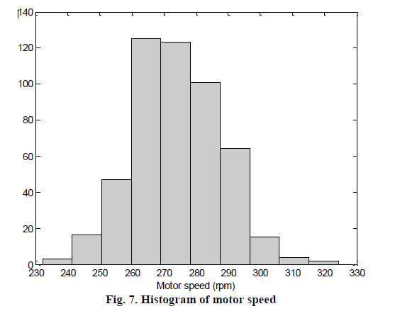

Student surveys:

Two student surveys were conducted in each semester for selected courses from Spring 2009 to Spring 2010, one in the beginning and one in the end of the semester. Students were asked to conduct self-evaluations of their knowledge in several key areas related to the course; one of these areas was statistics and its application in engineering. Students rank themselves with a score of 1-10, with 1 implying “know nothing about this area” and 10 implying “an expert in the area”. Since two surveys were available for each student, and the goal was to find out if the means for the scores were significantly improved, the most appropriate analysis tool is the paired t-test with the following hypotheses:

H0: (The averages of the self-evaluated student knowledge in statistics are the same in the beginning and end of the semester.)

H1: (The average of the self-evaluated student knowledge in statistics in the end of the semester is higher than that in beginning of the semester.)

The statistics from the student surveys are summarized in Table 5.

Table 5. Statistics of student surveys

|  |  |  |
| --- | --- | --- |
|  | Mean | Standard deviation |
| Beginning of semester | 4.38 | 1.97 |
| End of semester | 6.68 | 1.53 |
| Difference | 2.6 | 2.60 |
|  |  |  |

The paired t-test is to compare the following quantity to t0.05, 78 = 1.825

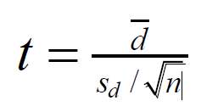 …. (3)

where n is the sample size, and equal to 78 in this analysis, d is the difference between the means of the two types of the problems, sd is the standard deviation of the difference, and t0.05, 78 is the value in the t-distribution table (Wortman et al. 2001). A 95% confidence level is used. The t value in equation (3) can be easily calculated using the statistics in Table 5 to be t = 6.17, which is greater than t0.05, 78. Therefore, with a confidence level of 95%, the null hypothesis H0 is rejected and the alternative hypothesis H1 is accepted. In other words, one can conclude that the students thought that their knowledge in statistics and its application in engineering improved after taking the course where statistics was taught using the new approach.

Use of statistical tools in course projects:

In the four courses being studied, before statistics was taught and applied using the new approach, 38% of the student course project reports included some statistical analysis; after the new approach was deployed that number increased to 78%, without a requirement for a statistical analysis from the course instructor.

In summary, the student self-evaluation and the use of statistical tools in course projects indicate that students have learned to use significantly more statistical analysis tools in evaluating the solutions to engineering problems.

CONCLUSION:

In this paper, the initial effort to increase the application of statistical tools in the EET program at Texas A&M University is discussed. Taking advantage of the extensive educational research in teaching and learning statistics, a unique approach of learning-by-using was adopted.

Statistical concepts such as mean, standard deviation, probability distribution, and variation in system parameters were introduced to students. Tools and methods such as Six Sigma, Design of Experiments, Monte Carlo analysis, and regression were illustrated with real-world examples. Students at different levels, from sophomore to senior, learned these concepts and tools in different courses with multiple immersions in to the field of statistics. Students used professional software extensively for statistical analysis.

The desired short term outcome was to make students comfortable using software to conduct statistical analysis in solving engineering problems. The approach of learning-by-using is efficient and effective for EET students. It is also more flexible than a single traditional statistics course, since the materials can be taught whenever appropriate in individual courses. The frequent use of statistical tools was found to have reinforced the student learning, based upon the review of student self-evaluations, and verification of the use of statistical tools in projects when they were not required. The long term goal of this new approach is to reduce the gap between what students learn in classroom and what they will face when entering the engineering profession.

It is worth noting that the learning-by-using approach provides an option to integrate statistics in ET programs, and it does not require another stand-alone engineering statistic course to be created. The relevance of the statistical analysis to the engineering problems faced by the students also increases students’ motivation for learning and using statistical tools. Students’ positive attitude towards statistics, as reflected in the self-evaluation, can make a significant difference in using statistical tools to solve problems in the future. Interested readers are referred to research results in the area of role of self-efficacy in problem solving (Pajares et al. 1994).

The preliminary results from the pilot project to increase the use of statistics are promising. The anticipated next step is to use the learning-by-using approach discussed in this paper, in as many courses in the EET curriculum as possible. Through frequent exposure to statistical tools, students will become more comfortable with statistics. The more they use the tools, the more they will appreciate the usefulness and effectiveness of these tools.

As an effort to continually improve the EET program, more data will be collected for evaluation of the effectiveness of the proposed statistics teaching method and presented to the TAC of ABET review committee. Future results will be quantitatively and qualitatively evaluated through student and faculty surveys and feedback from former students and industry. Results from this research effort will continue to be made available to the engineering education field through publications and presentations.

REFERENCES:

1. Allen, K. Stone, A. Rhoads, T.R., and Murphy, T.J. 2004. The Statistics Concepts Inventory: Developing a Valid and Reliable Instrument, ASEE Annual Conference.

**2**. Arnholt, A. T. 1997. Using Simulation as a Teaching Technique in Determining Power and Efficiency of Various Statistics, American Statistical Association Proceedings of the Section on Statistical Education, Alexandria, VA: American Statistical Association, pp. 143-147.

**3.** ASA Section on Statistical Education Committee on Training of Statisticians for Industry, 1980. Preparing Statisticians for Careers in Industry, The American Statistician, 34, pp. 65-75.

**4**. Barton, R.R., Nowack, C.A., Bisgaard, S., Czitrom, V., Spurrier, J. D., and Vardeman, S. 1998. A OneSemester, Laboratory-Based Quality-Oriented Statistics Curriculum for Engineering Students, The American Statistician, Vol. 52.

**5**. Bryce, G. R. 1993. Data Driven Experiences in an Introductory Statistics Course for Engineers Using Student Collected Data, Proceedings of the Section on Statistical Education, American Statistical Association, pp. 155-160.

**6.** Carr, R. 2002. Teaching statistics using demonstrations implemented with excel, ICOTS 6. **7**. Casella, G. 2004. Monte Carlo Statistical Methods, Springer.

**8**. delMas, R. C. Garfield, J., and Chance, B. L. 1999. A Model of Classroom Research in Action: Developing Simulation Activities to Improve Students' Statistical Reasoning, Journal of Statistics Education, 7(3).

**9**. Fernández de Carrera, E. T. 2006. Engineering statistical needs and engineering curriculum: an analysis, The Proceedings of ICOTS 7.